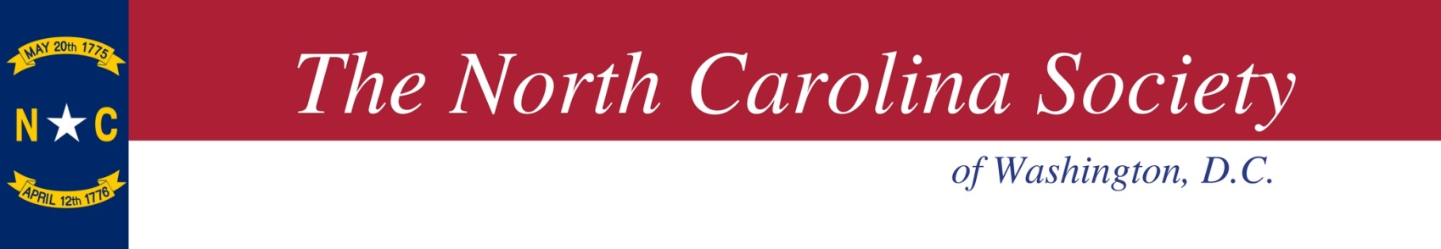
2024 NCS Officers

President
Greg Steele

1st Vice President
Elizabeth Adkins

2nd Vice President
Erin McBride

Treasurer
Brad Edwards

Secretary
Gordon Holzberg

Membership Sec/Delegate to NCSS
Chandler Mason

Historian
Debra Bryant

Chaplain
Wayne Boyles

Immediate Past President
Avery Weisel

THC Co-Chairs
Brad Edwards & Craig Saperstein

Board of Governors
John Bonus
Jacqueline Collie
Garrett Daniels
Megan Gallagher
James Hunter
Sean McCabe
Ryan Murphy
Katonya Pettaway
Katie Smith
Chad Sydnor
Evanne Timberlake
Huston Wallace

2024 Tar Heel Circle

Linking NC Business with Capitol Hill

The North Carolina Society invites you and/or your organization to become a member of the Tar Heel Circle (THC) for calendar year 2024.

North Carolina is proud to have one of the oldest state societies in our nation’s capital. By joining the Tar Heel Circle, you will be one of NCS’s sponsors and participate in our virtual and in-person events throughout the year with the North Carolina Congressional Delegation, current Executive Branch officials, business leaders from N.C., and North Carolinians living and working in Washington, DC.

In 2023, the North Carolina Society hosted monthly luncheon events featuring the N.C. Congressional Delegation, and officials from North Carolina in the current administration and the UNC System President. Additionally, we returned to our in-person Seafood Festival and BBQ & Bluegrass events.

The Tar Heel Circle will continue the tradition of hosting bipartisan monthly events which bring together leaders in government, business, academia, and non-profit organizations to discuss public policy issues important to the Old North State.

Previous featured speakers have included Members of the Congressional Delegation, Cabinet Officials, the Governor, Lt. Governor, Superintendent of Public Instruction, UNC System President, NC Community College System President, ACC Commissioner.

Thank you for your supporting the Tar Heel Circle.

2024 Sponsorships include the following:

2024 Tar Heel Circle Membership Categories
(Donor Board Based on In-Person Events)

Long Leaf Pine Member ($10,000)
- Membership in the Tar Heel Circle
- 10 tickets to BBQ and Seafood Festivals
- 4 tickets to THC/Delegation Events
- Recognition on NCSW website, invitations, and event signage

Old North State Member ($5,000)
- Membership in the Tar Heel Circle
- 6 tickets to BBQ and Seafood Festivals
- 2 tickets to THC/Delegation events
- Recognition on NCSW website, invitations, and event signage

Emerald Member ($2,500)
- Membership in the Tar Heel Circle
- 4 tickets to BBQ and Seafood Festivals
- 2 tickets to THC/Delegation events
- Recognition on NCSW website, invitations, and event signage

Cardinal Member ($1,000)
- Membership in the Tar Heel Circle
- 2 tickets to BBQ and Seafood Festivals
- 2 tickets THC/Delegation events
- Recognition on NCSW website, invitations and event signage

Dogwood Member ($500) (Individual)
- Membership in the Tar Heel Circle for an Individual
- 2 tickets to THC/Delegation events and receptions
- Recognition on NCSW website and event signage

For questions, contact THC co-chairs Brad Edwards (brad@jenkinshillconsulting.com), or Craig Saperstein (craig.saperstein@pillsburylaw.com),

2024 Tar Heel Circle - Calendar Year Membership
YES! I would like to support the North Carolina Society and enclosed is my membership in the 2024 Tar Heel Circle:

Membership Level and Amount Enclosed:

Organization Name:

Contact Person to Receive Meeting Notices:

Contact Person Email:

Contact Person Phone:

Please make checks payable to: North Carolina Society
If you would like to make payment via ACH draft, please contact Brad Edwards directly at brad@jenkinshillconsulting.com

Mail to: North Carolina Society
c/o Brad Edwards
403 Lloyds Lane
Alexandria, VA 22302

The North Carolina Society is a volunteer led social organization. Therefore, your donation is not a charitable contribution, but could be a business expense.
(TIN: 54-1257656).

W-9 and Invoices are available upon request. Please contact Brad Edwards, 202-744-0834, brad@jenkinshillconsulting.com, or Craig Saperstein, 202-255-0328, craig.saperstein@pillsburylaw.com

